Indigo NSEI Hedge Journal
To begin with the project I had to load several libraries in python such as yfinance, pandas, numpy and matplotlib. These libraries had different roles to play and layed foundation for future work. Pandas is the Excel on steroids. In finance, data is almost always tabular (rows and columns). Pandas allows you to handle thousands of rows of stock prices, calculate moving averages, and clean up missing data with just one or two lines of code (think of it as a single spreadsheet tab). While Pandas handles the tables, NumPy handles the heavy math. It is the engine under the hood. It’s used for fast array calculations—like calculating the daily returns or volatility of a portfolio—much faster than standard Python could. yFinance is the data tap. Instead of manually downloading CSV files from Yahoo Finance, this library lets call their API and stream historical stock prices, dividends, and company info directly into your Python script. Matplotlib sketchbook. You’ll use this to turn your numbers into line charts (stock price trends), histograms (distribution of returns), or scatter plots. The library uses function plt.plot() to visualize if ML model's predictions actually align with reality. Scikit-learn is the brain. It contains the actual Machine Learning algorithms. Whether you want to predict a price using Linear Regression or group similar stocks using Clustering, this library provides the pre-built tools to train and test your models.

I assigned spot to the INDIGO.NS returns from the year Jan 2018 to Jan 2024 and hedge to NSEI returns with same timeline as spot. Then I merged the two dataset just like using joins function in SQL
and dropped missing values using data.dropna()

For the next part I calculated log returns for both spot and hedge dataset by log(current/previous). This would essentially give me the ratio of change from yesterday’s return to today’s return and so on and so forth.
Then the natural next step was to visualize the spot vs hedge returns so I used matplolib to make a visual image representing the curves of both spot and hedge returns.
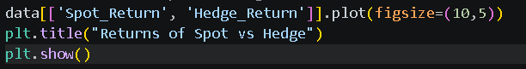
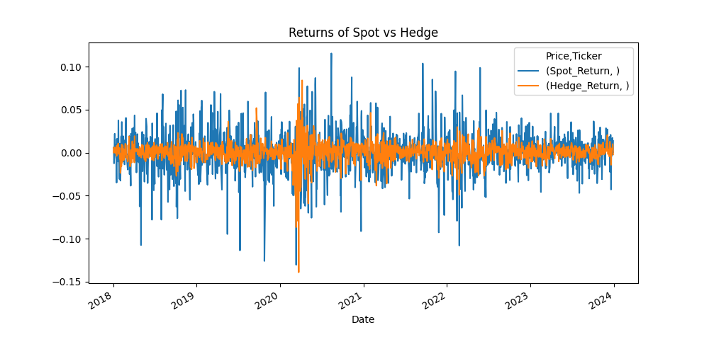
As we can see from the above image the returns ratio of (t) to (t-1) ranged from -0.15 to 0.10 through the years 2018 to 2024.
I also went ahead and calculated correlation between spot and hedge returns using .corr function in numpy library.
The correlation between the two as calculated by numpy library was 39.41 %, which I not a vey high correlation. In fact it is on a lower side of medium correlation as it is between 30-70%. This mean there is a positive correlation between hedge and spot returns; however, the hedge only tracks the spot price with a 39% magnitude.
Static Analysis
Then I went ahead and calculated beta by first calculating covariance between spot and hedge returns and variance of hedge.
$$β=\frac{cov\left(spot,hedge\right)}{var(hedge)}$$
This is particularly derived from the formula given in Hull
$β= ρ×\frac{σ\left(spot\right)}{σ\left(hedge\right)}$.
What a beta does essential is that it entails what percent of the total spot can effectively be hedge so a the variance of hedged returns is the minimum. Hence it depend a lot upon the correlation between the 2 datasets. If correlation is high then will also be high and vice versa. The purpose isn’t to maximize the hedge ratio (beta) and hedge all your investment to minimize the variance of the hedged return. Too much hedging leads to domination of hedging security(futures contract) to dictate the direction of the portfolio and too low of a hedge ratio leads to too much exposure of spot market on the underlying portfolio. Hence the best practice is to minimize hedged variance rather controlling the hedge ratio directly.
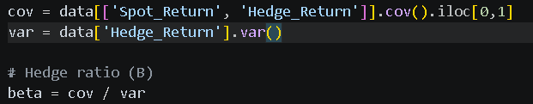
.iloc[0,1 function means 0 is for spot and 1 is for hedge hence cov matrix is between spot and hedge.
Then I calculated actual hedged returns using beta that I have just got and spot and hedge returns which I earlier calculated in the beginning . The difference between hedge returns and hedged return is quite important here. Hedge return is the returns that we get daily which is calculated by formula (t)/(t-1). And hedged return is the the profit we get after hedging the portfolio . it calculated by finding out the difference between the spot returns and hedge returns adjusted for the calculated beta.
Now to finish off static analysis I calculated last metric i.e., hedge effectiveness or R^2. It is done by first calculating variance of spot return and variance of hedged return and then using the following formula
$$R^{2}=1-\frac{hedge{d return}_{var}}{spot/{unhedged return}_{var}}$$
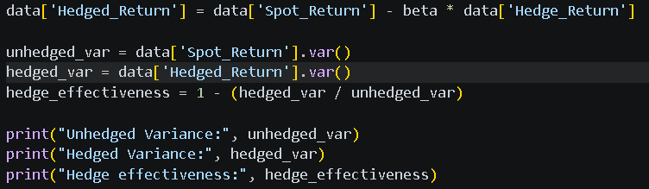
Now as the correlation is moderate between spot and hedge returns, the hedge effectiveness(R^2) is also moderate to low. Also there isn’t just systematic risk but also unsystematic risk(firm specific risk) present which cannot be captured by beta as it only takes into account systematic(market) risk. The final calculated hedge effectiveness under static analysis is 15% which is not very high and it is quite normal in finance hence a medium effective hedge.

Dynamic Analysis
Now it’s time to shift the pace of this analysis. If u look at the dataset then you’ll realise that the data we are working with is actually a time series data and static analysis might not be the best approach to go about calculating the several underlying metrics.
First, we can obtain rolling betas, which can be found making a window of some days. Here I have taken a window of 60 days so for first 60 days we have one beta and for 61st day(day 2 to day 61) we have another beta and for 62nd day(day 3 to day 63) we have another and so on and so forth. This way don’t jus get one beta but multiple betas for the multiple windows that we have created.
$$Rolling β=\frac{Rolling window cov\left(spot,hedge\right)}{Rolling window var(hedge)}$$
Then I went ahead and visualised the rolling beta to see the trend of multiple betas over the years 2018 to 2024
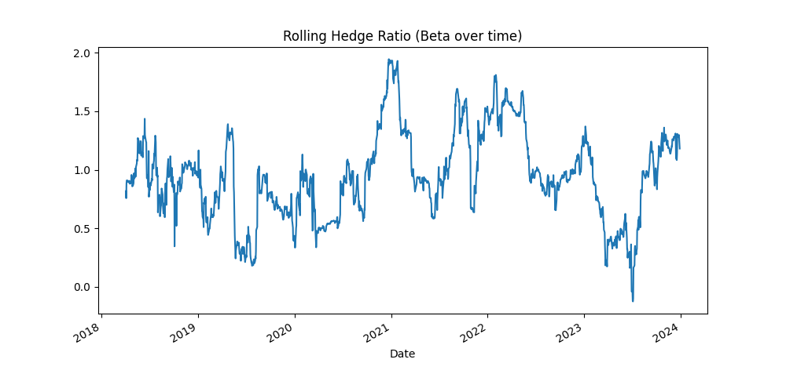
As evident from the image the rolling betas of window 60 ranged from0 to 2 through the period 2018 to 2024.
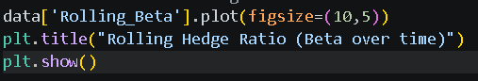
Now it is time to calculate the hedged return which is the profit we get from hedging the portfolio. It is essentially the difference between the spot returns and hedge return adjusted for rolling betas.
Now we have everything to finally calculate our hedge effectiveness which can be done by calculating R^2
$$Rolling hedge effectiveness=1-\frac{rolling hedged{ return}_{var}}{rolling spot/unhedged {return}_{var}}$$
The hedge effectiveness we get by using rolling betas is R^2 = 19%. It is observable from comparing the two R squares is that the hedge effectiveness takes a jump of around 400 basis points as compared to hedge effectiveness in static analysis where R^2 value is 15%
ML Analysis
For ML analysis I have to predict beta using several metrics. These metrics will act as inputs which will further predict beta instead of using OLS. The reason of using ML is mainly in order to check whether there is any non linear relationship between spot and hedged returns which cannot be captures by simple old. OlS beta will only capture the linear relationship as it uses covariance and variance between the two datasets to predict beta. In ML, we have used rolling volatility(standard deviation), lagged returns, volatility ratio, and basis risk,
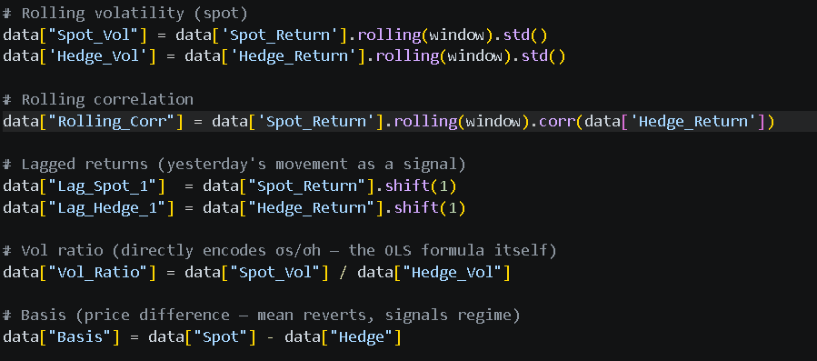
This is the benchmark and our ML model will be based on this. I assigned X to all the metrics above and is essentially the inputs which will go in my model. Then for the target/dependent variable I used future beta which is nothing but rolling beta shift(-1) which means it moves data up and takes the value from tomorrow and places it in today's row.
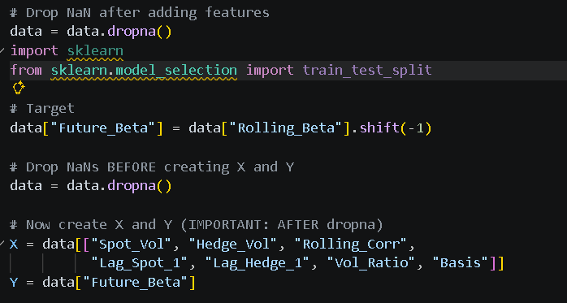
Now it was time for train-test split where is trained 80% of the data and test on rest 20% of the data. Normal train test split in python looks like train_test_split(X, Y, shuffle=True). But as i have time series financial data this would completely be wrong because I’ll be using future data to predict past which lead to look ahead bias/future leakage as it can train future data and test on past data.
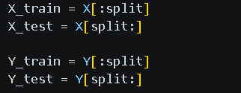

That’s a fair question. I didn’t apply ML blindly—I used it as a robustness check.
My starting point was the theoretical hedge ratio derived from OLS, which is optimal under linear assumptions.
I then tested whether there are any non-linear patterns or additional signals in the data using Random Forest model,
The fact that ML underperformed actually reinforced the conclusion that the hedge relationship is primarily linear and well-captured by classical methods.
So the goal wasn’t to replace OLS, but to validate whether a more complex model adds value—and in this case, it didn’t.

